Main Screens Commands

Preinitialize Events

//Hide Mode Buttons
vis bLSB,0
vis bUSB,0
vis bCWL,0
vis bCWU,0
//Hide IFS
vis hIFS,qIFS.picc //found bug by VE1BWV
//Hide Text Line for compatiable with Character LCD
vis t0,0
vis t1,0
vis nCWNum,0
vis tCWText,0
vis bAction,0
//Added Version 1.1
vis bStep1,0
vis bStep2,0
vis bStep3,0
vis bStep4,0
vis bStep5,0
pm.vv.val=-1
pm.vg.val=0
pm.sp.txt="J"
pm.sb.txt="^"
vis tDecode1,0
vDecodeVisible.val=0
if(nQuickMenu.val==1)
{
//CW Menu
qKey.picc=1
vis nQWPM,1
vis tQKeyType,1
vis b0,1
vis b1,1
vis b2,1
vis hATT,0
vis hIFS,0
vis nATT,0
vis nIFS,0
}else
{
//Normal
qKey.picc=0
vis nQWPM,0
vis tQKeyType,0
vis b0,0
vis b1,0
vis b2,0
vis hATT,1
vis hIFS,qIFS.picc
vis nATT,1
vis nIFS,1
}

TOUCH PRESS EVENTS
if(dim==0)
{
dim=dims
}

***TM1****
Events
if(pm.sp.txt!="J")
{
if(qInfo.picc==0)
{
qInfo.picc=1
fill 5,365,110,90,7
}
if(vDecodeVisible.val==1)
{
vis tDecode1,0
vDecodeVisible.val=0
}
sNewMax.txt=""
sys2=0
sys1=0
nTemp0.val=0
for(sys0=0;sys0<62;sys0++)
{
substr pm.sp.txt,sTemp0.txt,sys0*2,2
covx sTemp0.txt,sys2,2,2
//sys2/=2
if(sys1<sys2)
{
sys1=sys2
nTemp0.val=sys0
}
if(sys2<0)
{
sys2=0
}
if(sys2>100)
{
sys2=100 //was 90
}
substr sMax.txt,sTemp1.txt,sys0*2,2
covx sTemp1.txt,nTemp1.val,2,2
if(nTemp1.val<sys2)
{
nTemp1.val=sys2
}else
{
nTemp1.val*=9
nTemp3.val=sys2*1
nTemp1.val+=nTemp3.val
nTemp1.val/=10
}
covx nTemp1.val,sTemp1.txt,2,2
substr sTemp1.txt,sTemp1.txt,2,2
sNewMax.txt+=sTemp1.txt
if(sys0<18)
{
if(sys2>92) //was 82
{
sys2=92
}
if(nTemp1.val>92) //was 82
{
nTemp1.val=92
}
fill sys0*4+5,475-nTemp1.val,4,nTemp1.val,1342 //1500+sys1*2046
fill sys0*4+5,475-sys2,4,sys2,57343 //1500+sys1*2046
fill sys0*4+5,383,4,92-nTemp1.val,7 //1500+sys1*2046
}else
{
fill sys0*4+5,475-nTemp1.val,4,nTemp1.val,1342 //1500+sys1*2046
fill sys0*4+5,475-sys2,4,sys2,57343 //1500+sys1*2046
fill sys0*4+5,365,4,100-nTemp1.val,7 //1500+sys1*2046
}
//if(sys1>nADCDisVal.val) //maximum adc dccharget
//{
// sys2=sys1-nADCDisVal.val
//}
//sys2=sys1*90 //80%
//sys2/=100
}
sMax.txt=sNewMax.txt
if(sys1>50)
{
sys1=63488
}else if(sys1>40)
{
sys1=64528
}else if(sys1>30)
{
sys1=58584
}else if(sys1>20)
{
sys1=39566
}else if(sys1>10)
{
sys1=33549
}else
{
sys1=31727
}
nTemp0.val=nTemp0.val*47
nTemp0.val=nTemp0.val+30
cov nTemp0.val,sTemp0.txt,0
xstr 20,362,50,20,2,sys1,7,0,1,1,sTemp0.txt
//xstr 5,350,90,18,0,WHITE,10565,0,1,1,sTemp0.txt
//xstr 5,360,37,18,0,sys1,7,2,1,1,sTemp0.txt
pm.sp.txt="J"
}
if(pm.sb.txt!="^")
{
if(vDecodeVisible.val==0)
{
vis tDecode1,1
vDecodeVisible.val=1
}
strlen tDecode1.txt,sys0
if(sys0>23)
{
substr tDecode1.txt,tDecode1.txt,1,sys0-1
}
tDecode1.txt=tDecode1.txt+pm.sb.txt
pm.sb.txt="^"
}

***TIMER 2***
//If Graphic mode
if(nDispStatus.val==0)
{
add 17,0,jSMeter.val/3
}
sys2=pm.vq.val&0x07
if(sys2>0)
{
//check Now condition
//if(dim==0)
if(nSaverCount.val==-10) //Screen Saver Mode
{
//Screen Saver Mode
if(nLastFreq.val!=nSaverFreq.val)
{
dim=dims
nSaverCount.val=0
}
}else if(nSaverCount.val!=-20) //Screen off by remote control -> disabled screen saver, //always backlight off
{
//Running Mode
if(nLastFreq.val!=nSaverFreq.val)
{
nSaverFreq.val=nLastFreq.val
nSaverCount.val=0
}else
{
nSaverCount.val++
if(sys2==1)
{
if(nSaverCount.val>=180) //3 Min
{
dim=0
nSaverCount.val=-10
}
}else if(sys2==2)
{
if(nSaverCount.val>=600) //10 Min
{
dim=0
nSaverCount.val=-10
}
}else if(sys2==3)
{
if(nSaverCount.val>=1200) //20 Min
{
dim=0
nSaverCount.val=-10
}
}
}
}
}
if(pm.vg.val==74) //Loopback Process
{
pm.vg.val=-1
//sys0 : Sender, sys1 : Command
sys2=pm.vv.val //Loop back Value
pm.vv.val=0 //Init value for Next Receive process
sys0=sys2&0xFF //Sender
//Loopback Signal
if(sys0>4) //Sender < 5, ignore
{
sys2=sys2>>8
sys1=sys2&0xFF //Command
if(sys1==10) //Command : Backlight Off
{
sys2=sys2>>8 //
sys1=sys2&0xFF //Data1
sys2=sys2>>8 //Data2 (Checksum
sys2=sys2&0xFF
sys0=sys0+sys1+10 //sender + command(10) + data1
sys0=sys0%256
if(sys0==sys2) //Check Checksum
{
//Backlight Off
nSaverCount.val=-20 //Backlight off by Remote control
dim=0
}
}else if(sys1==11) //Command : Backlight On
{
sys2=sys2>>8 //
sys1=sys2&0xFF //Data1
sys2=sys2>>8 //Data2 (Checksum
sys2=sys2&0xFF
sys0=sys0+sys1+11 //sender + command(10) + data1
sys0=sys0%256
if(sys0==sys2) //Check Checksum
{
//Backlight Off
dim=dims
nSaverCount.val=0
}
}
}
}

CW Decode
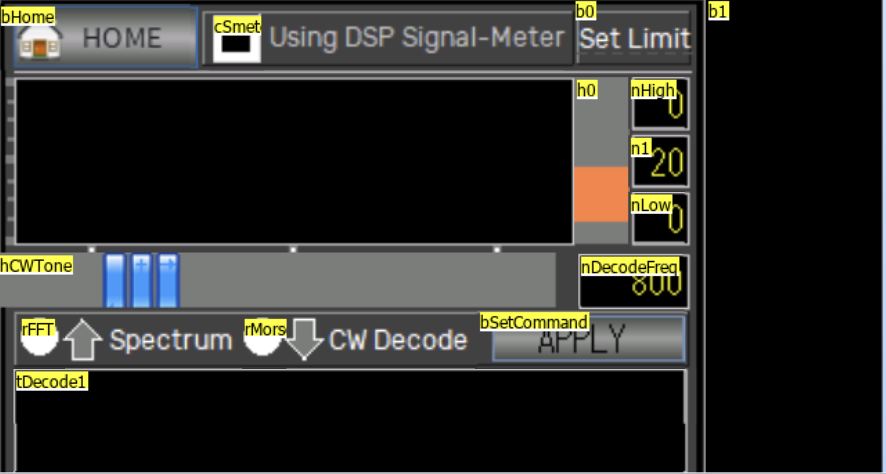

Preinitialize
pm.vv.val=-1
pm.vg.val=0
pm.sp.txt="J"
pm.sb.txt="^"

Buttons

bHome
TouchReleaseEvent
page px

cSmeterToUart (checkbox to enable remote processor)
TouchReleaseEvent
randset 5,255
nMyAddr.val=rand
//Send
pm.vn.val=-1
pm.vx.val=0
printh 59 /MAGIC
printh 58 //MAGIC
printh 68 /MAGIC
prints 74,1 //Command : LOOP BACK
prints nMyAddr.val,1 //Loop Sender :
sys0=50+cSmeterToUart.val //SMeterToUart
prints sys0,1 //Loop Command1 : Command Type / 95: Spectrum Mode
prints 0x6A,1 //Loop Command2 : Command Value / 0x6A to DSP
sys0=nMyAddr.val+sys0+0x6A
sys0=sys0%256
prints sys0,1 //Loop Command3 : Command Value / CheckSum
printh FF //MAGIC
printh FF //MAGIC
printh 73 //ETX

b0 (Set limit)
TouchReleaseEvent
randset 5,255
nMyAddr.val=rand
//Send
pm.vv.val=-1
pm.vg.val=0
sys1=146+h0.val
printh 59 //MAGIC
printh 58 //MAGIC
printh 68 //MAGIC
prints 74,1 //Command : LOOP BACK
prints nMyAddr.val,1 //Loop Sender :
prints sys1,1 //Loop Command1 : Command Type / 100~129: Decode Morse
prints 0x6A,1 //Loop Command2 : Command Value / 0x6A to DSP
sys0=nMyAddr.val+sys1+0x6A
sys0=sys0%256
prints sys0,1 //Loop Command3 : Command Value / CheckSum
printh FF //MAGIC
printh FF //MAGIC
printh 73 //ETX

b1 (Perhaps no opt?)
No events. 10 char max, defaults to empty string

h0 (slider)
TouchReleaseEvent
randset 5,255
nMyAddr.val=rand
//Send
pm.vn.val=-1
pm.vx.val=0
printh 59 //MAGIC
printh 58 //MAGIC
printh 68 //MAGIC
prints 74,1 //Command : LOOP BACK
prints nMyAddr.val,1 //Loop Sender :
sys0=146+h0.val //CW Limit
prints sys0,1 //Loop Command1 : Command Type
prints 0x6A,1 //Loop Command2 : Command Value / 0x6A to DSP
sys0=nMyAddr.val+sys0+0x6A
sys0=sys0%256
prints sys0,1 //Loop Command3 : Command Value / CheckSum
printh FF //MAGIC
printh FF //MAGIC
printh 73 //ETX

TouchMoveEvent
n1.val=h0.val*10

Max= 10, Min=0, Default=2

nHigh
No events

Defined as Decimal
Default 0

n0
No events

Defined as Decimal
Default 20

nLow
No events

Defined as Decimal
Default 0

nDecodeFreq
TouchPressEvent
sys0=hCWTone.val*50
nDecodeFreq.val=sys0+300

Default 800

hCWTone (slider)
TouchMoveEvent
click nDecodeFreq,1

Default 10, min 0, max 45

rFFT (radio button 1)
TouchPressEvent
if(rFFT.val==1)
{
rMorse.val=0
}
//else
//{
// rMorse.val=1
//}

rMorse (radio button 2)
TouchPressEvent
if(rMorse.val==1)
{
rFFT.val=0
}
//else
//{
// rFFT.val=1
//}

bSetCommand (apply)
TouchPressEvent
randset 5,255
nMyAddr.val=rand
//Send
pm.vv.val=-1
pm.vg.val=0
if(rFFT.val==1) //Spctrum Mode
{
sys1=95
}else if(rMorse.val==1)
{ //Morse Decode
sys1=nDecodeFreq.val-300
sys1/=50
sys1+=100 //Decode Morse 100~129
}else
{
sys1=94
}
printh 59 //MAGIC
printh 58 //MAGIC
printh 68 //MAGIC
prints 74,1 //Command : LOOP BACK
prints nMyAddr.val,1 //Loop Sender :
prints sys1,1 //Loop Command1 : Command Type / 100~129: Decode Morse
prints 0x6A,1 //Loop Command2 : Command Value / 0x6A to DSP
sys0=nMyAddr.val+sys1+0x6A
sys0=sys0%256
prints sys0,1 //Loop Command3 : Command Value / CheckSum
printh FF //MAGIC
printh FF //MAGIC
printh 73

tDecode1
TouchPressEvent
None

String length 30

tDecode2
TouchPressEvent
None

String length 30

tDecode3
TouchPressEvent
None

String length 30

***Timer 1***
if(pm.sp.txt!="J")
{
//fill 0,0,240,70,BLACK
//vMaxValue.val=0
//vMinValue.val=30000
//sys1=nDecodeFreq.val/48
sys1=nDecodeFreq.val/50
sys1=sys1+1
vSelectMin.val=sys1-1
vSelectMax.val=sys1+1
sys1=sys1*4
sys2=0
for(sys0=0;sys0<62;sys0++)
{
substr pm.sp.txt,sTemp0.txt,sys0*2,2
covx sTemp0.txt,sys2,2,2
sys2/=2
if(sys2<0)
{
sys2=0
}
if(sys2>70)
{
sys2=70
}
//if(vMaxValue.val<sys2)
//{
// vMaxValue.val=sys2
//}
//if(vMinValue.val>sys2)
//{
// vMinValue.val=sys2
//}
//sys1=sys0*2
//sys1+=194
//fill sys0*2,71-sys2,2,sys2,YELLOW //1500+sys1*2046
//fill sys0*2,0,2,71-sys2,BLACK //1500+sys1*2046
//fill sys0*4,240-sys2,4,sys2,YELLOW //1500+sys1*2046
//fill sys0*4,170,4,70-sys2,BLACK //1500+sys1*2046
fill sys0*4+9,110-sys2,4,sys2,YELLOW //1500+sys1*2046
fill sys0*4+9,39,4,71-sys2,BLACK //1500+sys1*2046
if(sys0>vSelectMin.val)
{
if(sys0<vSelectMax.val)
{
line sys1,40,sys1,109,RED
line sys1+4,40,sys1+4,109,RED
}
}
//if(sys1>nADCDisVal.val) //maximum adc dccharget
//{
// sys2=sys1-nADCDisVal.val
//}
//sys2=sys1*90 //80%
//sys2/=100
}
pm.sp.txt="J"
//Draw Decode Frequency
//sys1=nDecodeFreq.val/48
//sys1=sys1*4
//sys1+=4 //drop bin0 of FFT
//fill sys1,0,2,71,RED
//Graph LIne
//fill 9,110-n1.val,246,1,BLUE
//Needle
//line sys1,40,sys1,109,RED
//line sys1+4,40,sys1+4,109,RED
//Display High and Low value
//sys0=nHigh.val*7
//sys1=vMaxValue.val*3
//sys0+=sys1
//sys0/=10
//nHigh.val=sys0
//sys0=nLow.val*7
//sys1=vMinValue.val*3
//sys0+=sys1
//sys0/=10
//nLow.val=sys0
//fill 9,110-nHigh.val,246,1,GRAY
//nRecvCount.val--
//nArriveValue.val=0
//if(nRecvCount.val<1)
//{
// click b1,1
//}
}else if(pm.sb.txt!="^")
{
if(vLineIndex.val==0)
{
tDecode1.txt=tDecode1.txt+pm.sb.txt
strlen tDecode1.txt,sys0
if(sys0>23)
{
vLineIndex.val=1
}
}else if(vLineIndex.val==1)
{
tDecode2.txt=tDecode2.txt+pm.sb.txt
strlen tDecode2.txt,sys0
if(sys0>23)
{
vLineIndex.val=2
}
}else if(vLineIndex.val==2)
{
strlen tDecode3.txt,sys0
if(sys0>23)
{
tDecode1.txt=tDecode2.txt
tDecode2.txt=tDecode3.txt
tDecode3.txt=""
}
tDecode3.txt=tDecode3.txt+pm.sb.txt
}
pm.sb.txt="^"
}else if(vReadStep.val==0)
{
vReadStep.val=1
pm.vv.val=-1
pm.vg.val=0
//Read Configuration from DSP
randset 5,255
nMyAddr.val=rand
printh 59 //MAGIC
printh 58 //MAGIC
printh 68 //MAGIC
prints 74,1 //Command : LOOP BACK
prints nMyAddr.val,1 //Loop Sender :
prints 2,1 //Loop Command1 : Command Type / 1~5: Read Configuration
prints 0x6A,1 //Loop Command2 : Command Value / 0x6A to DSP
sys0=nMyAddr.val+2+0x6A //Byte0 + Byte1 + Byte2 % 256 = Checksum
sys0=sys0%256
prints sys0,1 //Loop Command3 : Command Value / CheckSum
printh FF //MAGIC
printh FF //MAGIC
printh 73 //ETX
}else if(vReadStep.val==1)
{
if(pm.vg.val==0x6A) //Response from DSP
{
vReadStep.val=2
sys0=pm.vv.val&0xFF
sys1=pm.vv.val>>8
sys1=sys1&0xFF
sys2=pm.vv.val>>16
sys2=sys2&0xFF
//sys0 : magLimit
//sys1 : SMeterToUart
//sys2 : DSPType and Morse Decode HZ
if(sys0>100)
{
sys0=100
}
n1.val=sys0
sys0=sys0/10
h0.val=sys0
if(sys1==1)
{
cSmeterToUart.val=1
}else
{
cSmeterToUart.val=0
}
if(sys2==95)
{
rFFT.val=1
rMorse.val=0
}else if(sys2>=100)
{
if(sys2<146)
{
rFFT.val=0
rMorse.val=1
hCWTone.val=sys2-100
//nDecodeFreq.val=sys2
click nDecodeFreq,1
}
}
pm.vv.val=-1
pm.vg.val=0
}
}

Variables
nMyAddr: Number 0
sTemp0: String Max length 10
vReadStep: Number 0
vSelectMin: Number 0
vSelectMax: Number 0
vLineIndex: Number 0

Spectrum
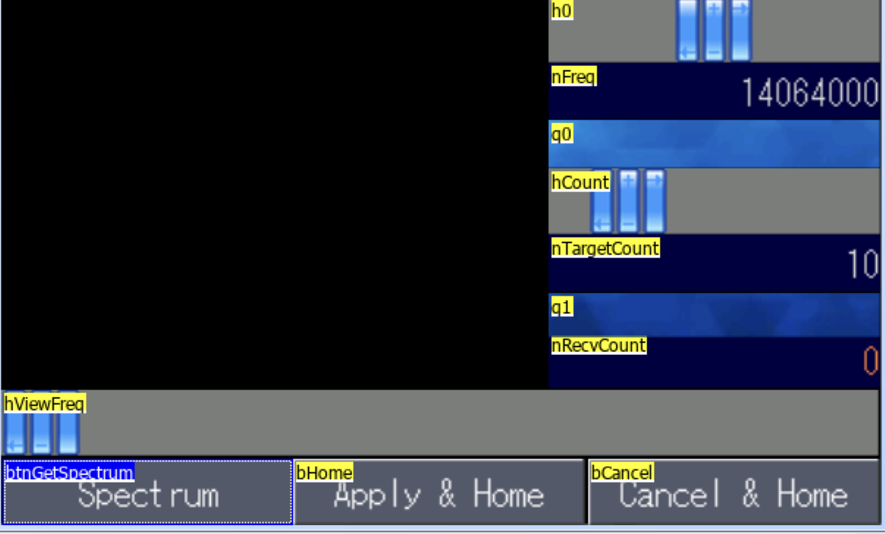

Preinitialize
//Send Default Value
click bOption,1
nFreq.val=px.nLastFreq.val
nBeforeFreq.val=px.nLastFreq.val
vis bOption,0

Buttons

btnGetSpectrum
TouchPressEvent
if(nRecvCount.val<1)
{
if(nFreq.val>30000)
{
printh 59 //MAGIC
printh 58 //MAGIC
printh 68 //MAGIC
prints 16,1 //Command : Start Spectrum
sys0=nFreq.val
sys0=2000*nADCCount.val/2 //2k step
sys0=nFreq.val-sys0
print sys0 //Start Frequency
printh FF //MAGIC
printh FF //MAGIC
printh 73 //ETX
nRecvCount.val=nTargetCount.val
nStartFreq.val=sys0
fill 0,52,247,113,BLACK
}
}

bHome
TouchReleaseEvent
page px

bCancel
TouchReleaseEvent
//Set Frequency
printh 59 //MAGIC
printh 58 //MAGIC
printh 68 //MAGIC
prints 2,1 //Set Frequency
print nBeforeFreq.val //VALUE
printh FF //MAGIC
printh FF //MAGIC
printh 73 //ETX
page px

hViewFreq
TouchMoveEvent
nIsChangeFreq.val=1
Min:0, Max:245: Default=1

h0 (slider)
TouchPressEvent
nPressValue.val=nFreq.val

TouchReleaseEvent
nPressValue.val=0
h0.val=500

TouchRMoveEvent
if(nPressValue.val>10000)
{
sys0=h0.val-500
sys0*=50
nFreq.val=nPressValue.val+sys0
}

Max:1000, Min:0 Default:500

nFreq
No events - probably current frequency

q0
No events - picc 15 -spacer from background color

hCount
Touch Release Event
pm.vn.val=-1
pm.vx.val=0
//nStep.val=2000 //2Kh
nADCCount.val=120 //MAX : 120
printh 59 //MAGIC
printh 58 //MAGIC
printh 68 //MAGIC
prints 15,1 //Command : Spectrum Option
//printh 20 //Send Count
prints hCount.val,1 //Send Count (Scan Set Count)
printh 00 //ADC Value Offset (Spectrum Value = ADC Value - (Offset * 3)
prints nADCCount.val,1 //ADC Scan Count (120 - MAX Value)
sys0=2000/20
prints sys0,1 //Increase Step * 20 (ex 100 = 2Khz Step Scan)
printh FF //MAGIC
printh FF //MAGIC
printh 73 //ETX
//tm0.en=1
nTargetCount.val=hCount.val

Min: 2, Max:50, Default:10

nTargetCount
Look like just variable

q1
No events - picc 15 -spacer from background color

nRevCount
Look like just variable

***Timer tm0***
if(pm.sh.txt!="J")
{
fill 0,52,247,70,BLACK
for(sys0=0;sys0<120;sys0++)
{
substr pm.sh.txt,tmpS.txt,sys0*2,2
covx tmpS.txt,sys1,2,2
sys2=sys1-sys2
if(sys2<0)
{
sys2=0
}
if(sys2>70)
{
sys2=70
}
//Draw
fill sys0*2,122-sys2,2,sys2,YELLOW//1500+sys1*2046
if(sys2>40)
{
sys2=40
nTemp.val=RED
}else if(sys2>20)
{
nTemp.val=63910
}else if(sys2>15)
{
nTemp.val=64463
}else if(sys2>10)
{
nTemp.val=64940
}else if(sys2>8)
{
nTemp.val=YELLOW
}else if(sys2>3)
{
nTemp.val=48608
}else if(sys2>2)
{
nTemp.val=44352
}else
{
nTemp.val=25376
}
fill sys0*2,164-sys2,2,sys2,nTemp.val//1500+sys1*2046
// if(sys1>nADCDisVal.val) //maximum adc dccharget
// {
// sys2=sys1-nADCDisVal.val
// }
if(sys1>7) //maximum adc discharge
{
sys2=sys1-7
}
}
pm.sh.txt="J"
nRecvCount.val--
if(nRecvCount.val==0)
{
if(nSelectFreq.val>350000)
{
printh 59 //MAGIC
printh 58 //MAGIC
printh 68 //MAGIC
prints 2,1 //Set Frequency
print nSelectFreq.val //VALUE
printh FF //MAGIC
printh FF //MAGIC
printh 73 //ETX
}
}
}

***Timer tmrDisplay***
sys2=0
if(nBeforeBase.val!=nFreq.val)
{
sys2+=1
}
if(nBeforePos.val!=hViewFreq.val)
{
sys2+=1
}
if(sys2>0)
{
nBeforeBase.val=nFreq.val
nBeforePos.val=hViewFreq.val
fill 0,0,247,52,10565
fill 0,25,247,2,16959
fill 120,10,2,15,16959
cov nFreq.val,tmpS.txt,0
xstr 126,4,90,18,0,WHITE,10565,0,1,1,tmpS.txt
sys0=nFreq.val
sys0=2000*nADCCount.val/2 //2k step fixed
sys0=nFreq.val-sys0
nStartFreq.val=sys0
cov nStartFreq.val,tmpS.txt,0
xstr 2,4,90,18,0,WHITE,10565,0,1,1,tmpS.txt
//fill 0,160,247,20,31727
fill 0,164,247,14,10565
fill 0,173,247,2,16959
sys0=hViewFreq.val
sys0=sys0*1000
sys1=sys0+nStartFreq.val
nSelectFreq.val=sys1
cov nSelectFreq.val,tmpS.txt,0
//xstr 150,26,90,24,2,64520,GRAY,2,1,1,tmpS.txt
if(hViewFreq.val>120)
{
xstr hViewFreq.val-92,28,90,24,2,64520,10565,2,1,1,tmpS.txt
}else
{
xstr hViewFreq.val+2,28,90,24,2,64520,10565,0,1,1,tmpS.txt
}
fill hViewFreq.val,0,2,50,64520
fill hViewFreq.val,164,2,14,64520
}

***Timer tmrSetFreq***
if(nIsChangeFreq.val==1)
{
if(nRecvCount.val==0)
{
if(nSelectFreq.val>350000)
{
if(nSelectFreq.val<57000000)
{
printh 59 //MAGIC
printh 58 //MAGIC
printh 68 //MAGIC
prints 2,1 //Set Frequency
print nSelectFreq.val //VALUE
printh FF //MAGIC
printh FF //MAGIC
printh 73 //ETX
}
}
}
nIsChangeFreq.val=0
}

Misc Variables
Tmp5: String max 10
nPressValue: Number 0
nADCCount: Number 0
nStartFreq: Number 0
nSelectFreq: Number 0
nBeforeFreq: Number 0
nBeforePos: Number 0
nBeforeBase: Number 0
nBeforeBase: Number 0
nIsChangeFreq: Number 0

